PRÁTICA 5

Larissa Magalhães Pereira

13747904

1. Arquivo em anexo (dinpop.arff)

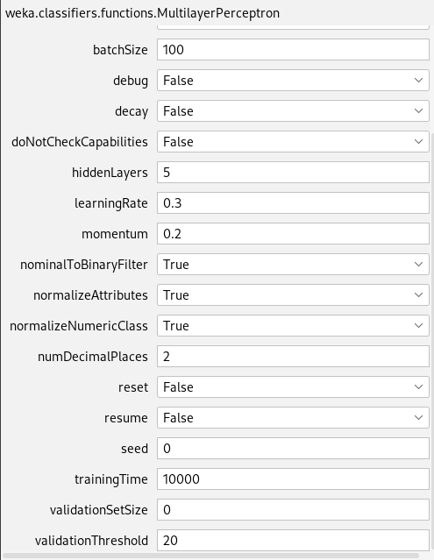

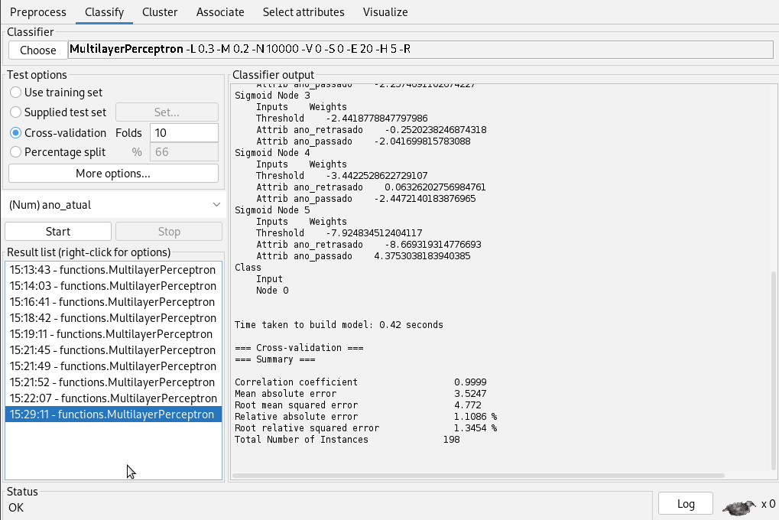

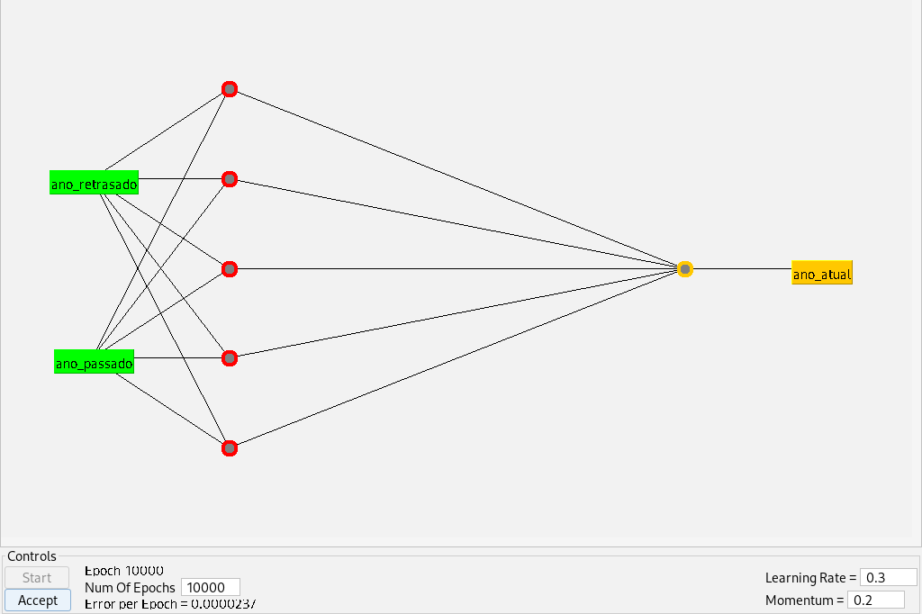

=== Run information ===

Scheme: weka.classifiers.functions.MultilayerPerceptron -L 0.3 -M 0.2 -N 10000 -V 0 -S 0 -E 20 -H 5 -R

Relation: population

Instances: 198

Attributes: 3

ano_retrasado

ano_passado

ano_atual

Test mode: 10-fold cross-validation

=== Classifier model (full training set) ===

Linear Node 0

Inputs Weights

Threshold 1.8580937203987697

Node 1 -5.3190309719959235

Node 2 -2.106707930628191

Node 3 -2.0949482702354034

Node 4 -3.7367420016498327

Node 5 2.9669612138163957

Sigmoid Node 1

Inputs Weights

Threshold -2.094196821090617

Attrib ano_retrasado -0.5535054530660813

Attrib ano_passado 2.2613795348549677

Sigmoid Node 2

Inputs Weights

Threshold -2.428945984798322

Attrib ano_retrasado 0.1530306822313657

Attrib ano_passado -2.2574691102674227

Sigmoid Node 3

Inputs Weights

Threshold -2.4418778847797986

Attrib ano_retrasado -0.2520238246874318

Attrib ano_passado -2.041699815783088

Sigmoid Node 4

Inputs Weights

Threshold -3.4422528622729107

Attrib ano_retrasado 0.06326202756984761

Attrib ano_passado -2.4472140183876965

Sigmoid Node 5

Inputs Weights

Threshold -7.924834512404117

Attrib ano_retrasado -8.669319314776693

Attrib ano_passado 4.3753038183940385

Class

Input

Node 0

Time taken to build model: 0.42 seconds

=== Cross-validation ===

=== Summary ===

Correlation coefficient 0.9999

Mean absolute error 3.5247

Root mean squared error 4.772

Relative absolute error 1.1086 %

Root relative squared error 1.3454 %

Total Number of Instances 198